Wheel in the middl eof support path – more basleine for all other joints
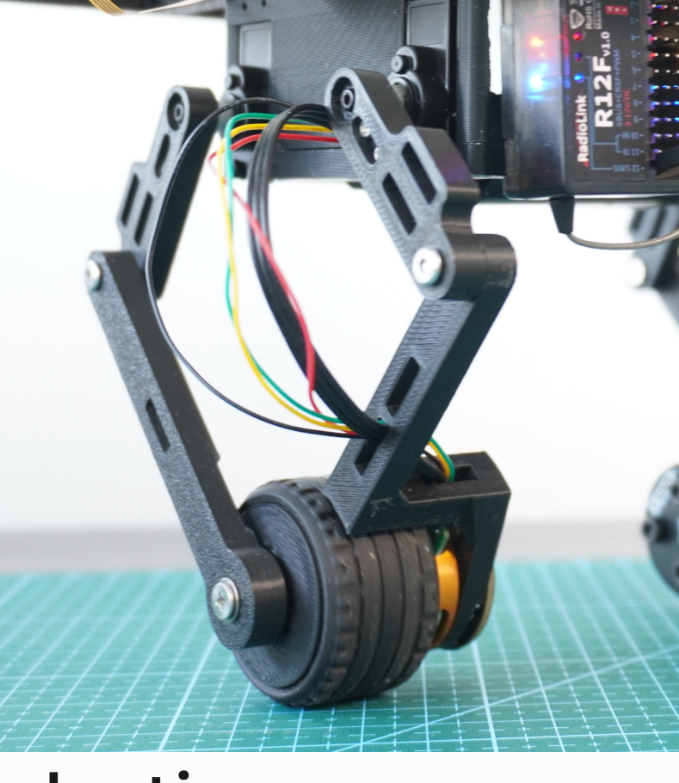
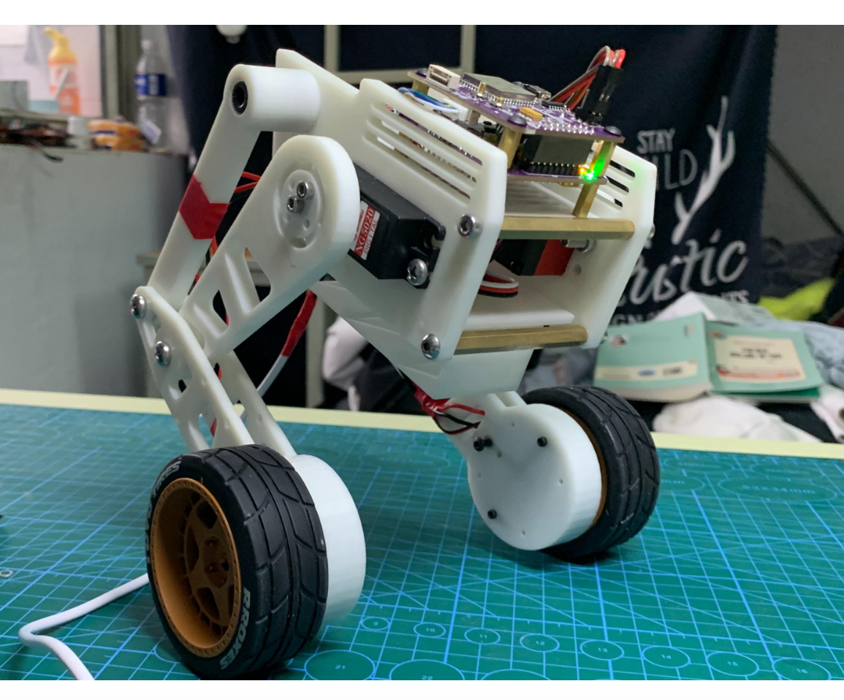
3d printed material as shaft with reinforcing screw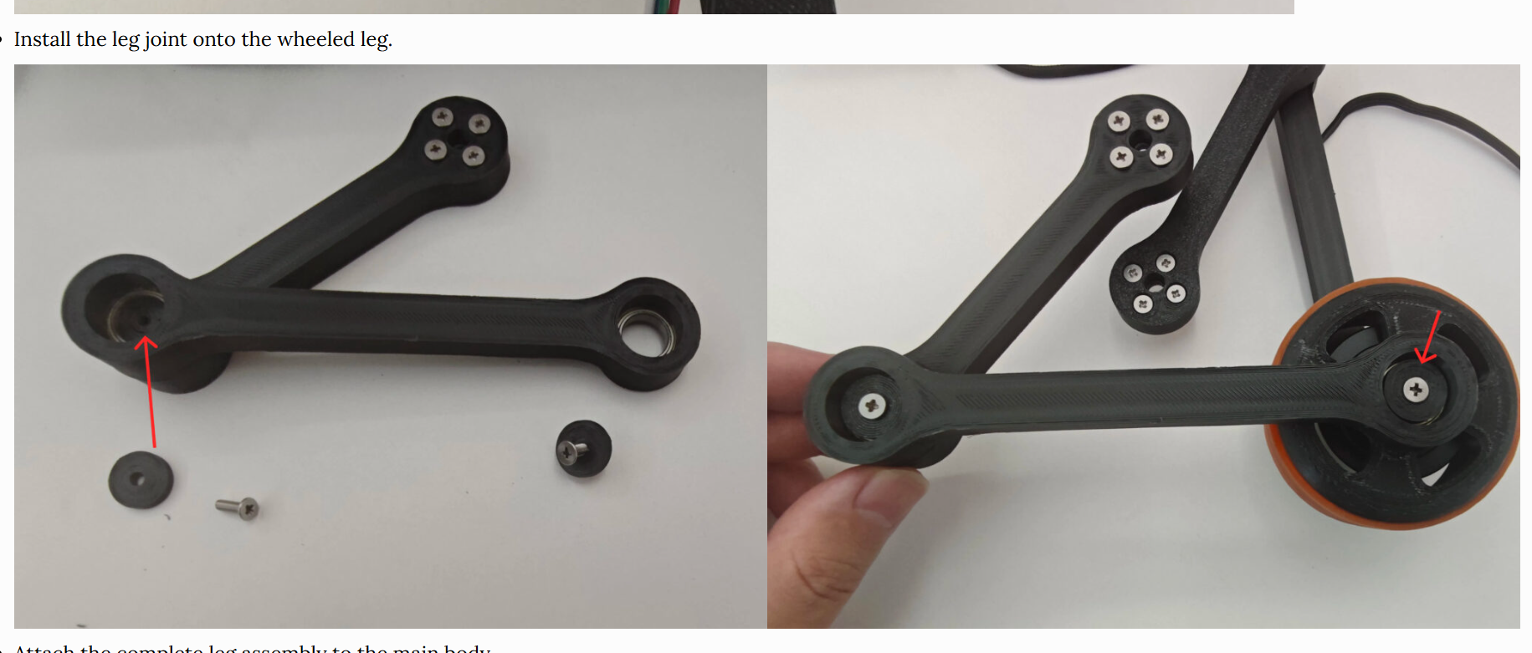
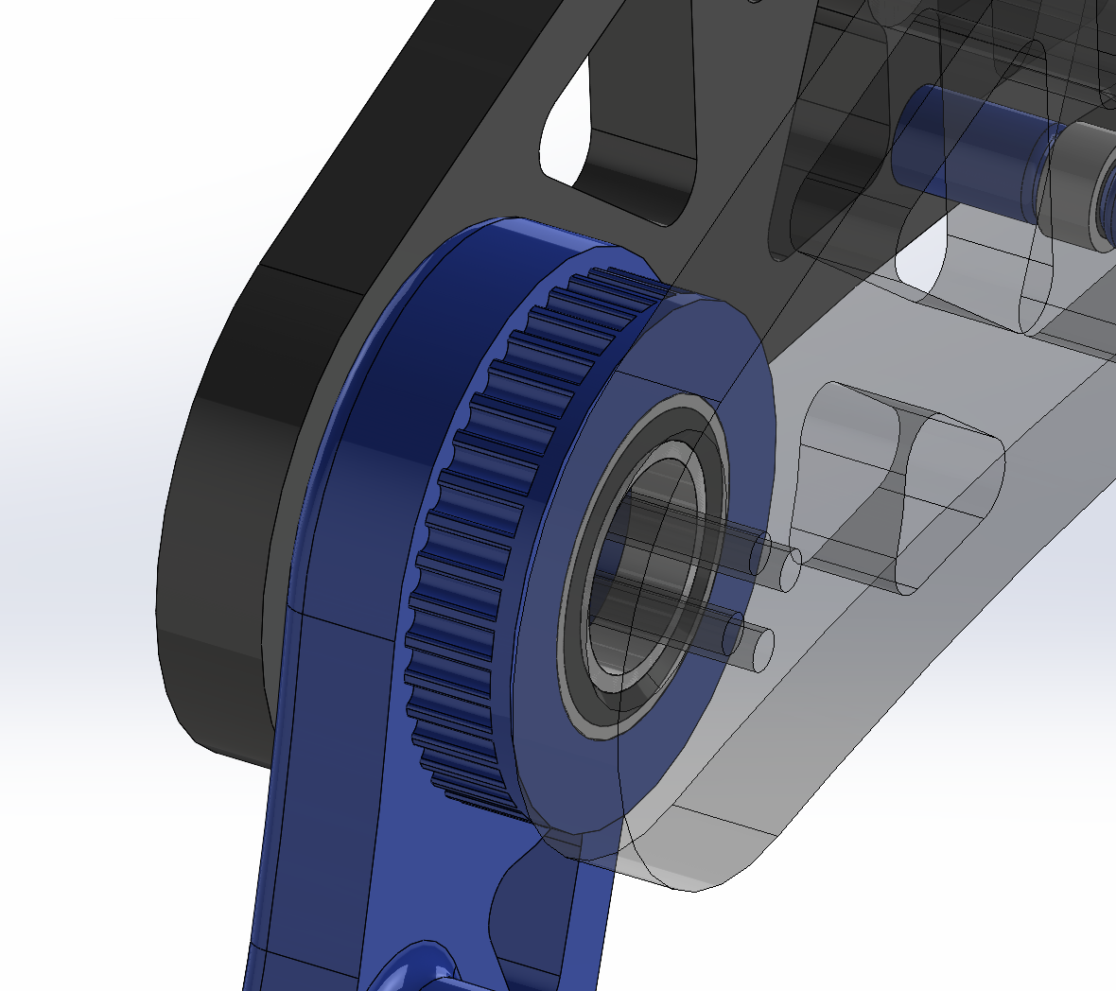
https://frankfu.blog/embodied-ai-robot/wheeled-legged-robot-es-01-building-with-esp32-simplefoc/ reinforced with screws in middle – no need for precise shaft.

3d printed material acts as thrust washer 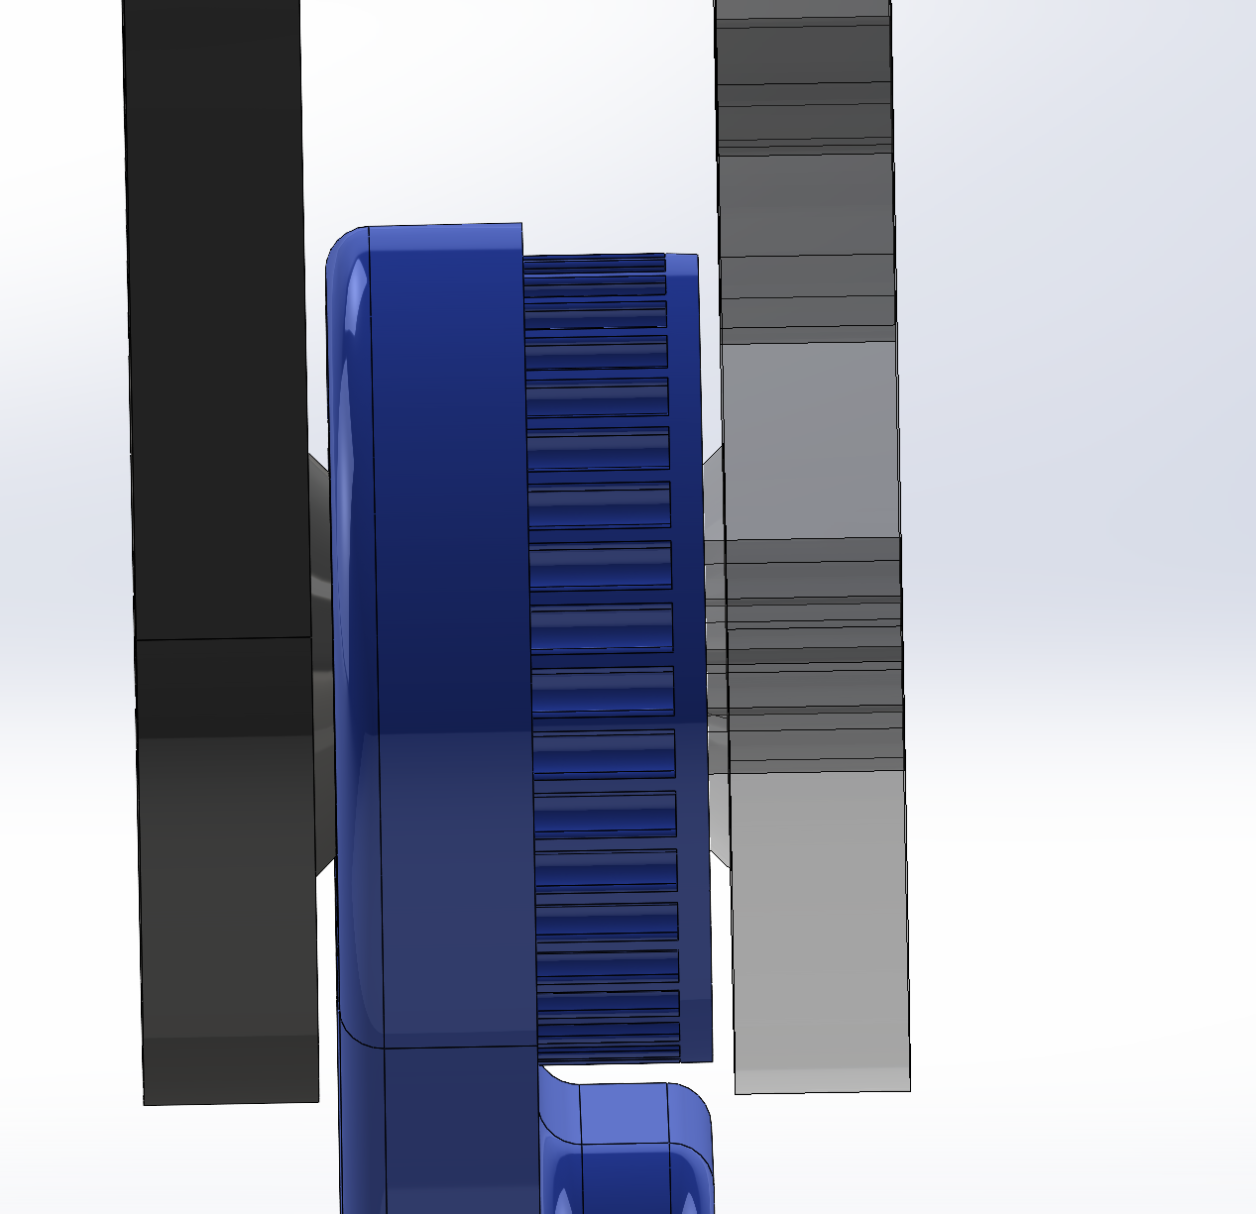

put hip motor and coupler link below box.
wlloes for femur to be double jointed? femur
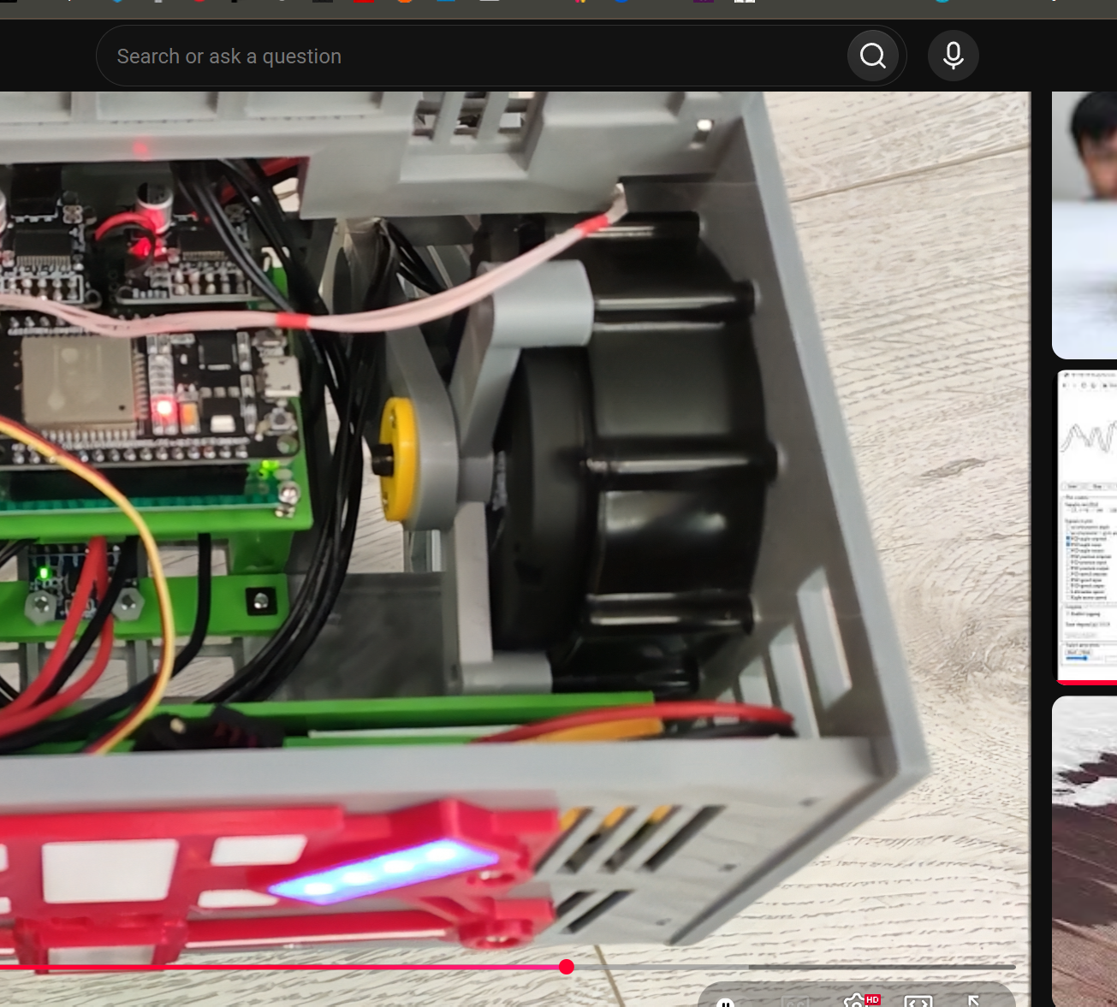
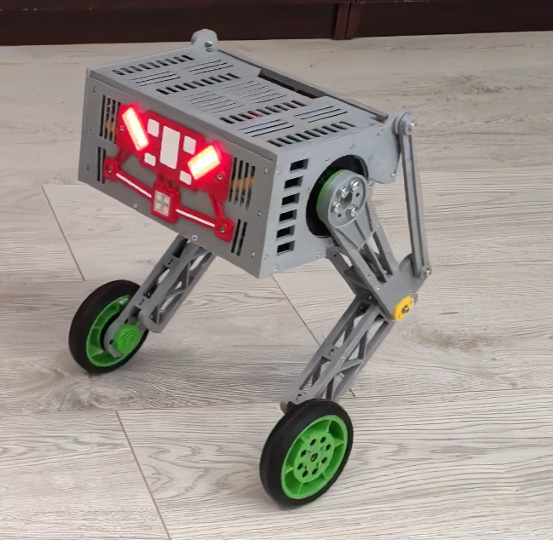
https://www.youtube.com/watch?v=4QwVZERZFA8
Double coupler?

More baseline between bearings.

Center wheel contact point with beam?
Wheels as close to motor.

Reinforce PLA with AL?

Couplers share shaft
Add bearing on opposite side of wheel?

Need to be able to tighten a lot

Shaft on middl elink, not yoke. Ball bearings or bushing on yoke end for more baseline.

